Digital family life skills for 21st century clinicians
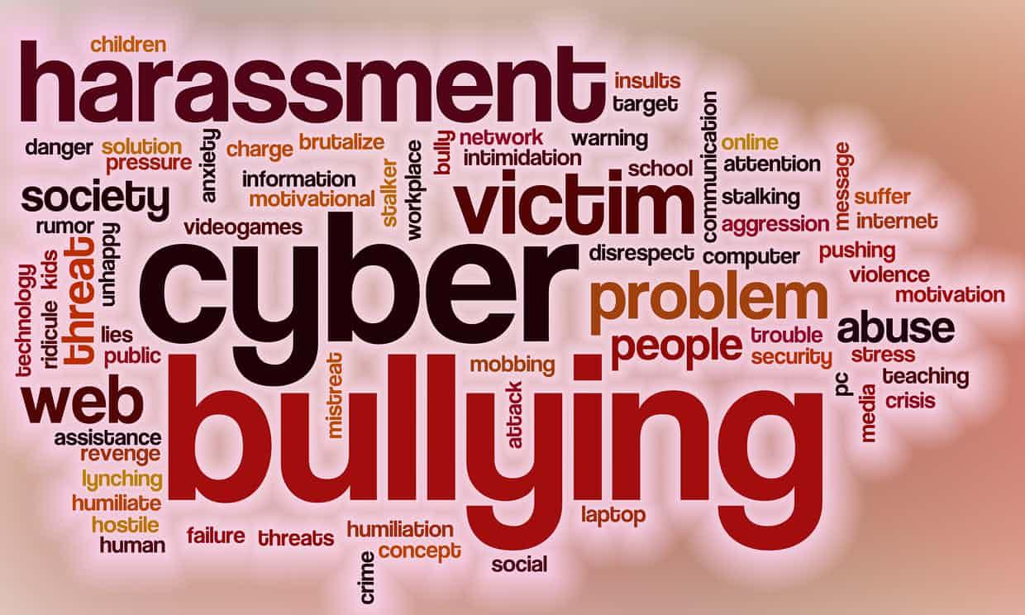
Innovation Workshop
With the greatly increased use of social media by young people, concern is growing over it’s impact on many aspects of their mental health as well as family life in general.
This innovative workshop presents mental health professionals with an opportunity to develop new templates for responding effectively to the unprecedented challenges they now face.

Digital Family Life Skills for 21st Century Families and Clinicians.
Participant, CAHMS, Aldershot: “The idea of using curiosity, context and a relational focus to address these issues has shifted my thinking from a fearful position to a more curious and hopeful one.”
Participant, NHS, Dorset: “This hugely useful workshop increased my confidence in addressing digital media challenges and how I might approach this professionally and personally.”
Do you feel that your training and experience has not equipped you to deal with clinical issues which stem from our clients’ digital social worlds?
Does it often seem as if the familiar boundaries which defined our clients’ private and public social worlds (and our relationship to them) are being undermined?
Are you losing confidence in your own sense of professional agency and your ability to work with this new generation of digitally sponsored problems, issues, contexts and dilemmas?
This is hardly surprising given that digital technologies are now disrupting family life in terms of:
- The transitions between developmental stages
- The roles, relationships and expectations between family members
- Fundamental issues about authority, identity and relations to peer group norms and pressures
This workshop is an opportunity for clinicians and mental health professionals to renegotiate their relationship to the complex and ubiquitous digital technologies that so often bewilder our professional lives as well as those of our clients.
Workshop Goals
- To empower participants to make the shift from a position of fear and unsafe uncertainty to a position of curiosity and safe uncertainty
- To help participants to replace feelings of impotence or of being de-skilled with a renewed sense of agency and confidence when dealing with digital media related issues.
- To develop their critical discernment and ability to make informed judgements about issues such as internet addiction, sexting, grooming, cyberbullying and the way that these are covered in the media.
- To enable them to see beyond the medical/addiction model to relational, cultural, socio-technical and political ways of framing the issues.
- To understand the clinical implications of research in this area and access a diverse range of age and stage issue appropriate clinical interventions and innovations.
- To develop their own maps of key digital life stages, rites of passage and parenting styles.
- To help participants discern and identify chronic, acute and at-risk clients and families.
- To work with a model that prioritises relationships and clinical wisdom rather than generationally specific technological expertise.
The workshop comprises up-to-date research presentations and facilitated exploration of their clinical implications, curated videos, group discussions, experiential exercises, case vignettes in addition to recommendations for clinical interventions.
The workshop can be tailored to one or two days and time can also be allocated to emerging clinical innovations such as emotional mapping and family social media policies as well guidance with regards to relevant online resources to aid further study.
About the workshop designer-facilitators:
Dr. Reenee Singh is the Founding Director of the London Intercultural Couples Centre and the co-director of the Tavistock Family Therapy and Systemic Research Centre. She was the Editor of the Journal of Family Therapy for whom she commissioned and edited a special issue of the Journal of Family Therapy on social media and the family. She provides consultation to the media and to parents and professionals on digital life skills for families.
Mr. Stephen Fitzpatrick is director of the online environmental campaigning organisation Altforest. He was formerly Group Interactive Strategist for Saatchi and Saatchi and Social Media Director for Golley Slater, the UK Public Relations Network. He is the author of the ‘Mindful Media Manifesto’ and has over 20 years of digital experience with public, private and charitable organisations including Greenpeace, WWF, Oxfam, Design Council, HSBC, Visa and LLoyds.
For more information about the workshop and/or bookings and availability please contact Dr Reenee Singh at reeneesingh@gmail.com

